Lecture Notes in Artificial Intelligence:
Authors’ Instructions for the Preparation
Yu Han1, Caifeng Guo1

1 School of Business, Changzhou University, Changzhou, Jiangsu 213159, P. R. China, hanyu@cczu.edu.cn
Abstract. The abstract should summarize the contents of the paper and should contain at least 90 and at most 350 words. It should be set in 9-point font size and should be inset 1.0 cm from the right and left margins. There should be two blank (10-point) lines before and after the abstract. This document is in the required format.
Keywords: We would like to encourage you to list your keywords in this section.Three to five key words.
1 Introduction
This instruction file for Word users may be used as a template. Kindly send the final and checked Word and PDF files of your paper to the Contact Editor. This is usually one of the organizers of the conference. You should make sure that the Word and the PDF files are identical and correct and that only one version of your paper is sent. Please note that we do not need the printed paper.
Every detail, including the order of the names of the authors, should be checked before the paper is sent to the Editors.
1.1 Checking the PDF File
Kindly assure that the Contact Editor is given the name and email address of the contact author for your paper. Once the files have been worked upon, a copy of the final pdf of each paper will be send to its contact author. The contact author is asked to check through the final pdf to make sure that no errors have crept in during the transfer or preparation of the files. This should not be seen as an opportunity to update or copyedit the papers, which is not possible due to time constraints. Only errors introduced during the preparation of the files will be corrected.
In some cases, it is the Contact Volume Editor that checks all the pdfs. In such cases, the authors are not involved in the checking phase.
1.2 Seminar Meeting Reply Slip Forms
Please send your Seminar meeting reply slip form to the Contact Volume Editor, either as a scanned PDF or Word. Digital signatures are acceptable.
2 Paper Preparation
Use 10-point type for the name(s) of the author(s) and 9-point type for the address(es) and the abstract. For the main text, please use 10-point type and single-line spacing. We recommend the use of Computer Modern Roman or Times. Italic type may be used to emphasize words in running text. Bold type and underlining should be avoided.
We would therefore urge you not to squash your paper.
Headings. Headings should be capitalized (i.e., nouns, verbs, and all other words except articles, prepositions, and conjunctions should be set with an initial capital) and should, with the exception of the title, be aligned to the left. Words joined by a hyphen are subject to a special rule. If the first word can stand alone, the second word should be capitalized. The font sizes are given in Table 1.
Table 1. Font sizes of headings. Table captions should always be positioned above the tables.
Heading level | Example | Font size and style
Title (centered) | Lecture Notes … | 14 point, bold
1st-level heading | 1 Introduction | 12 point, bold
2nd-level heading | 2.1 Printing Area | 10 point, bold
3rd-level heading | Headings. Text follows … | 10 point, bold
4th-level heading | Remark. Text follows … | 10 point, italic
Lemmas, Propositions, and Theorems. The numbers accorded to lemmas, propositions, and theorems, etc. should appear in consecutive order, starting with Lemma 1, and not, for example, with Lemma 1.1.
2.1 Figures
Please check that the lines in line drawings are not interrupted and have a constant width. Grids and details within the figures must be clearly legible and may not be written one on top of the other. Figures should be numbered and should have a caption which should always be positioned under the figures, in contrast to the caption belonging to a table, which should always appear above the table. Please center the captions between the margins and set them in 9-point type (Fig. 1 shows an example). The distance between text and figure should be about 8 mm, the distance between figure and caption about 6 mm.
To ensure that the reproduction of your illustrations is of a reasonable quality, we advise against the use of shading. The contrast should be as pronounced as possible. If screenshots are necessary, please make sure that you are happy with the print quality before you send the files.
Remark 1. Illustrations are generally black and white (halftones). If you send colored figures that are to be printed in black and white, please make sure that they really are legible in black and white. Some colors show up very poorly when printed in black and white.
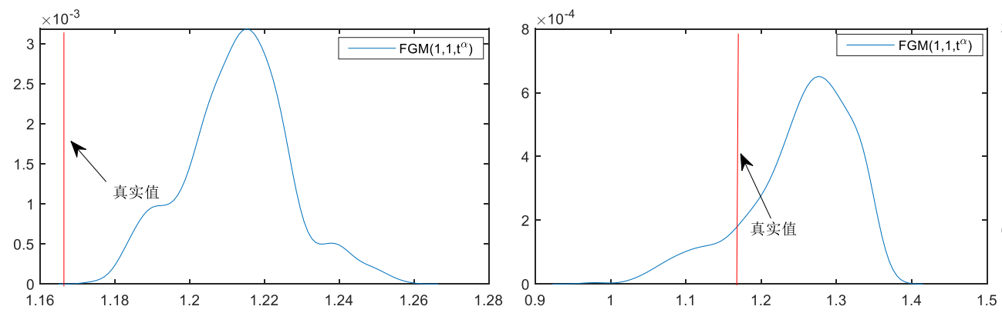
Fig. 1. One kernel at xs (dotted kernel) or two kernels at xi and xj (left and right) lead to the same summed estimate at xs. This shows a figure consisting of different types of lines. Elements of the figure described in the caption should be set in italics, in parentheses, as shown in this sample caption.
2.2 Formulas
Displayed equations or formulas are centered and set on a separate line (with an extra line or halfline space above and below). Displayed expressions should be numbered for reference. The numbers should be consecutive within each section or within the contribution, with numbers enclosed in parentheses and set on the right margin.
$$H(B_{n}^{q})=\sum_{p=1}^{n−1}{\left[\frac{1}{t_{n}−t_{p}}⋅\text{sign}(B_{p}^{q})\right]}$$ | ()

Equations should be punctuated in the same way as ordinary text but with a small space before the end punctuation mark. If there are mathematical formulas, please use the built-in editor of word or mathtype to edit the formulas (do not directly paste pictures). All formulas in the text are uniformly and consecutively numbered, with the formula numbers placed within parentheses.
2.3 Footnotes
The superscript numeral used to refer to a footnote appears in the text either directly after the word to be discussed or – in relation to a phrase or a sentence – following the punctuation mark (comma, semicolon, or period). Footnotes should appear at the bottom of the normal text area, with a line of about 5cm set immediately above them.
2.4 Program Code
Program listings or program commands in the text are normally set in typewriter font, e.g., CMTT10 or Courier.
Example of a Computer Program from Jensen K., Wirth N. (1991) Pascal user manual and report. Springer, New York
program Inflation (Output)
{Assuming annual inflation rates of 7%, 8%, and
10%,... years};
const MaxYears = 10;
var Year: 0..MaxYears;
Factor1, Factor2, Factor3: Real;
begin
Year := 0;
Factor1 := 1.0; Factor2 := 1.0; Factor3 := 1.0;
WriteLn('Year 7% 8% 10%'); WriteLn;
repeat
Year := Year + 1;
Factor1 := Factor1 * 1.07;
Factor2 := Factor2 * 1.08;
Factor3 := Factor3 * 1.10;
WriteLn(Year:5,Factor1:7:3,Factor2:7:3,
Factor3:7:3)
until Year = MaxYears
end.
2.5 Citations
For citations in the text please use square brackets and consecutive numbers: [1], [2], [3], etc.
2.6 Page Numbering and Running Heads
There is no need to include page numbers. If your paper title is too long to serve as a running head, it will be shortened. Your suggestion as to how to shorten it would be most welcome.

Acknowledgments. The heading should be treated as a 3rd level heading and should not be assigned a number.
3 The References Section
Please base your references on the examples below. References that don’t adhere to this style will be reformatted by Springer. You should therefore check your references thoroughly when you receive the final pdf of your paper. The reference section must be complete. You may not omit references. Instructions as to where to find a fuller version of the references are not permissible.
References
1. Smith, T.F., Waterman, M.S.: Identification of Common Molecular Subsequences. J. Mol. Biol. 147, 195--197 (1981)
2. May, P., Ehrlich, H.C., Steinke, T.: ZIB Structure Prediction Pipeline: Composing a Complex Biological Workflow through Web Services. In: Nagel, W.E., Walter, W.V., Lehner, W. (eds.) Euro-Par 2006. LNCS, vol. 4128, pp. 1148--1158. Springer, Heidelberg (2006)
3. Foster, I., Kesselman, C.: The Grid: Blueprint for a New Computing Infrastructure. Morgan Kaufmann, San Francisco (1999)
4. Czajkowski, K., Fitzgerald, S., Foster, I., Kesselman, C.: Grid Information Services for Distributed Resource Sharing. In: 10th IEEE International Symposium on High Performance Distributed Computing, pp. 181--184. IEEE Press, New York (2001)
5. Foster, I., Kesselman, C., Nick, J., Tuecke, S.: The Physiology of the Grid: an Open Grid Services Architecture for Distributed Systems Integration. Technical report, Global Grid Forum (2002)
6. National Center for Biotechnology Information, http://www.ncbi.nlm.nih.gov

The footnote numeral is set flush left and the text follows with the usual word spacing.

